G. SWIFT AND THE LAST OF ENGLISH IDENTITY

- Born in London in 1949, he was educated at the University of Cambridge. Last Orders was written in 1996 and won the Booker Prize.

- The timeline: the narration spans over a few decades in the form of flashbacks, ranging from episodes during WWII to the 1990s. The narration in the present takes place on 2nd April 1990, but most of the recalled action takes place in the 1960s, a time when old certainties were crumbling in front of a rapidly changing world.

- The main plot is linear: before dying of cancer, Jack Dodds had expressed the wish to have his ashes scattered into the sea at Margate, Kent, in South-East England. His three best friends, Vic, Lenny and Ray, and his adopted son, Vince, set on a trip, while his wife Amy chooses to go and visit their disabled daughter in hospital, whom Jack had never accepted.

- The narration of the journey, in the present tense, is interrupted by the memories of the different characters in the past: not just the four friends, but also Amy, Jack and Vince’s wife, Mandy, intervene. Episodes of their lives are recalled and many secrets and “things not told” come out.

- The characters are all lower-class, living in Bermondsey, South London, and speaking Cockney, a dialect of London’s East End.

ENGLISHNESS REVISITED: THE DECONSTRUCTION OF MASCULINITY

- The lines along which the narrative runs are those of class and gender, in particular masculinity and patriarchy are under analysis.

- Swift accounts for the crisis of identity, in particular of the white male lower-class head of family, that took place in the 1960s, and unmasks the ideology and prejudice on which his authority was based; in the end, nevertheless, it is not clear whether Swift is more critical towards them or nostalgic for their disappearance.

- The ambiguity stems from the fact that, on the one side, he actually deconstructs these traits of identity and society, and puts them into doubts; on the other, he is sympathetic with these features, mourns their loss and tries to recover them by fostering unit.

- The crisis of masculinity and of patriarchy is epitomised by the fact that daughters and sons do not obey their parents, and wives do not obey their husbands: Lenny’s daughter, Sally, carries out an illegal abortion and becomes a prostitute; Ray’s daughter, Sue, flees to Australia and his wife, Carol, leaves him; Jack’s wife, Amy, has a relationship with Ray; Jack cannot exert any paternal authority over Vince.

- Jack’s death symbolises the final loss of a traditional masculine model: he represented the stereotypical working-class Englishman, a strong, aggressive, rough, stout hard-worker and heavy-drinker, he embodied the “real man”.

- Jack’s death, hence the loss of a model, triggers a reflection from his mates as to their roles and lack of authority:

- Vince and Lenny try to embody the male model but they fail: despite being strongly racist, Vince depends on an Egyptian businessman to conclude a bargain that would save his business (symbolic for 1956); Lenny’s daughter marries an underdog.
- Vic represents a different masculinity: he is peaceful, thoughtful, almost feminine (he drinks half pints; he enrolled in the Navy, not in the Army) but his personality never comes out.
- Ray is the only one looking for change. He eventually decides to travel abroad and dissociates himself from the other men, who stand for stasis. He represents masculinity in flux.

- In the end, what emerges from their reflections is that Jack’s masculinity was constructed and encoded, it comes out of a role play based on binary oppositions vs. women, who only in appearance have a marginal role in the novel, in fact they are the main actors.
ENGLISHNESS REVISITED: PLACES OF HISTORY AND IDENTITY

- The title also introduces the reader to a man’s world: “last orders” refers to Jack’s wishes but also to the pub, a symbolic place where the narrative and the trip start.

- All along the journey, the four lads stop at places that are symbolic for English history and cultural identity: the pub, Chatham War Memorial, Wick's Farm (which stands for the countryside and Rural England), Kent ("The Garden of England"), Canterbury Cathedral and finally Margate.

- Their visit to these iconic and evocative places should help them restore a sense of unity, but they will find out more conflicts and will realise they have never been so split > unity and identity cannot be recovered by means of symbols that have ossified and have lost any meaning > these symbols are now empty because they have turned into icons, that is, "postcards" of England, (stereo)typical places of collective memory and identity.
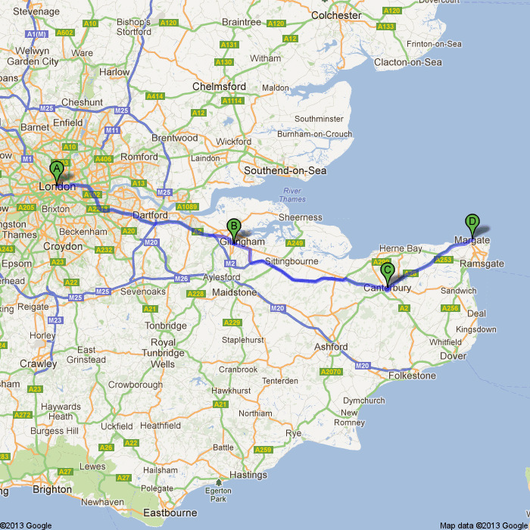

A= Bermondsey, South London; B= Chatham; C= Canterbury; D= Margate

- Last Orders is a novel loaded with stereotypes, commonplaces, proverbs and clichés that create caricature and parody, and are deployed to show that they cannot hold any longer; some critics have read these devices as an attempt to affirm and recover English identity.

- Swift shows the limits of this stereotypical masculinity and the inadequacy of this version of Englishness: discourses of masculinity and of national identity are intertwined and sink together.

- Margate is a symbolic “end of the road”, the end of an Englishness based on masculinity, patriarchy, hierarchy and memories of Empire.

